2009 High School Survey of Student Engagement
Indiana University Center for Evaluation and Education Policy
(103 Schools, 27 States)
- Only two percent of students said they'd never been bored in school.
- Just 41 percent of the students in the 2009 survey responded that they went to school because of what they learn in classes.
- Only 23 percent said they went because of their teachers.
- Around a third said they went because they enjoy being in school.
- Students who have thought about dropping out continue to cite a lack of engagement with the school as a reason: 50 percent said they considered dropping out because they didn't like the school; 39 percent said they considered it because they didn't like the teachers; 42 percent said they thought of dropping out because they didn't see the value in the work they were asked to do.

Student engagement occurs when students make a psychological investment in learning. They try hard to learn what school offers. They take pride not simply in earning the formal indicators of success (grades), but in understanding the material and incorporating or internalizing it in their lives (Newmann, F. (1992) Student Engagement and Achievement in American Secondary Schools).

Engagement versus disaffection in school refers to the intensity and emotional quality of children's involvement in initiating and carrying out learning activities (Connell & Wellborn, 1991; Skinner, 1991).

Engagement can best be understood as a relationship: between the student and school community, the student and school adults, the student and peers, the student and instruction, and the student and curriculum. (Yazzie-Mintz (2010) Charting the Path from Engagement to Achievement)

Student Engagement is the extent to which all learners

(1) are motivated and committed to learning,

(2) have a sense of belonging and accomplishment, and

(3) have relationships with adults, peers, and parents that support
learning.

Indicators include attendance rate and participation rates in extracurricular activities. Students need to be engaged before they can apply higher order, creative thinking skills. They learn most effectively when the teacher makes sense and meaning of the curriculum material being taught. This can only happen if the teacher has created a safe learning environment that encourages students to meet challenges and apply high rigor skills to real-world, unpredictable situations inside and outside of school.
International Center for Leadership in Education

Student Engagement is multi-faceted:
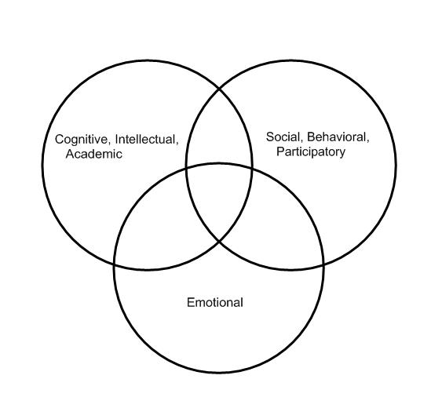

Essential Questions:
- What is student engagement?
- How does student engagement relate to student performance/achievement?
- How can our work lead to increased student engagement?
- What elements must we include in our lessons/units to increase student engagement?

